Integration of Jenkins with Maven & GitHub

~By Krishan Rupani

GitHub is​ a multinational corporation that provides hosting for software development​ and version control using Git.

# Prerequisites

* Maven Installed, running
* Jenkins running

In this module, we will see how to integrate Jenkins with Maven and GitHub.

Make sure your Jenkins is up and running.

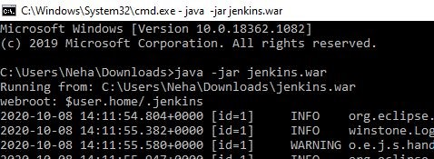

Open jenkins in web browser, I will be using Chrome

“Localhost:8080”

On left-hand side, move to manage Jenkins.

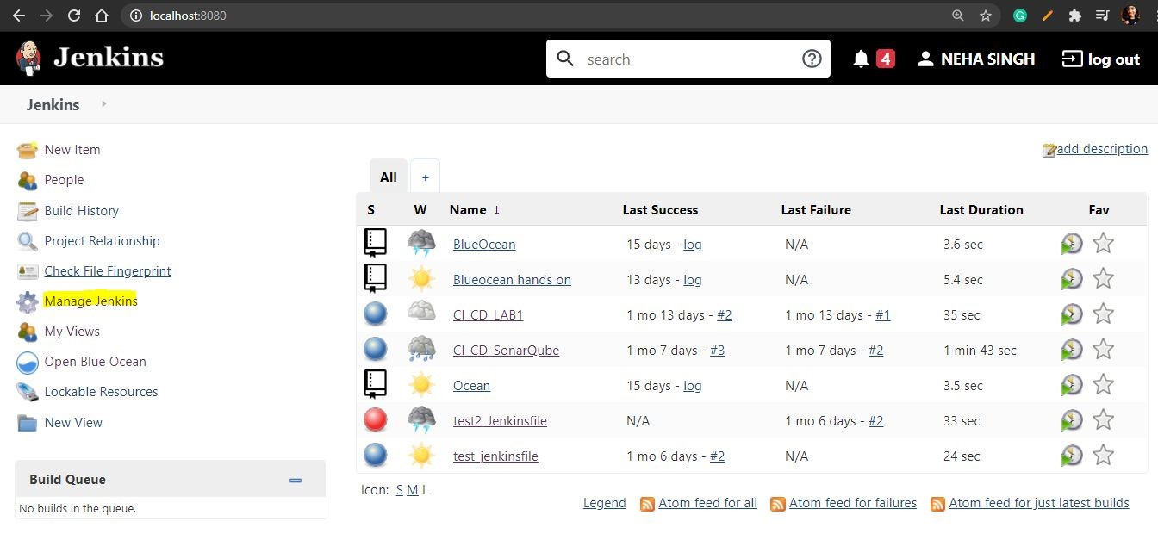

Manage Plugins

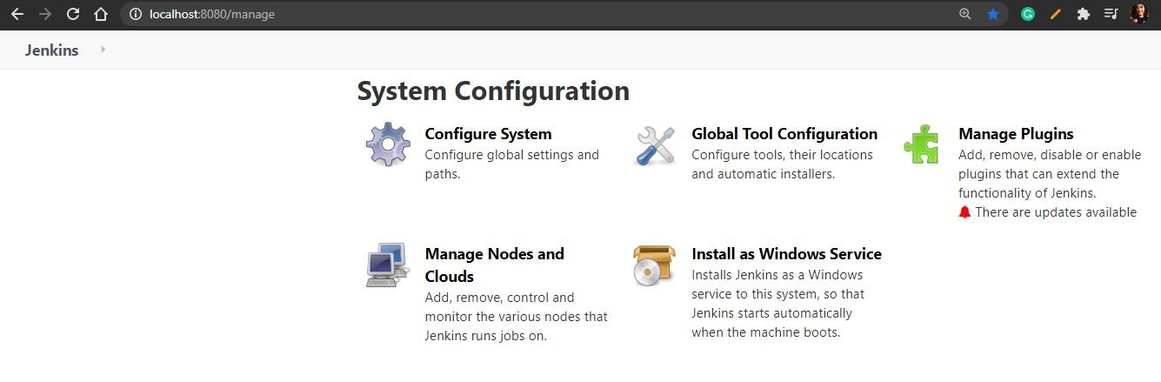

Now, you can install

​

Maven, Github Plugins



If you do not have GitHub Account, move to [https://github.com](https://github.com/)​ [/](https://github.com/)

Enter credentials

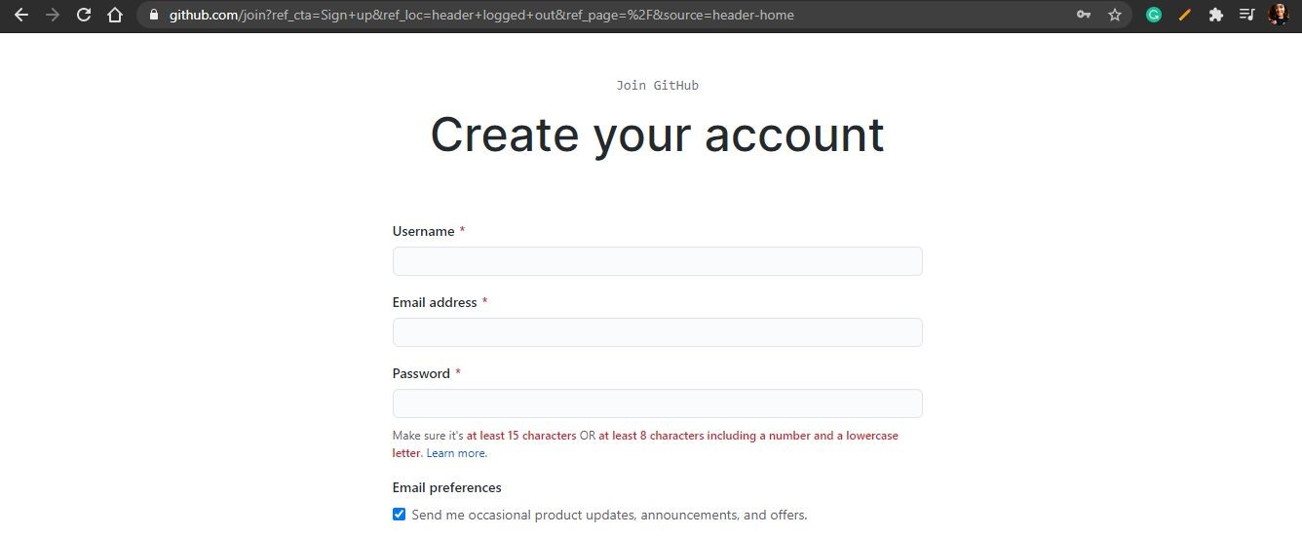

You will see account like this, but without repositories.

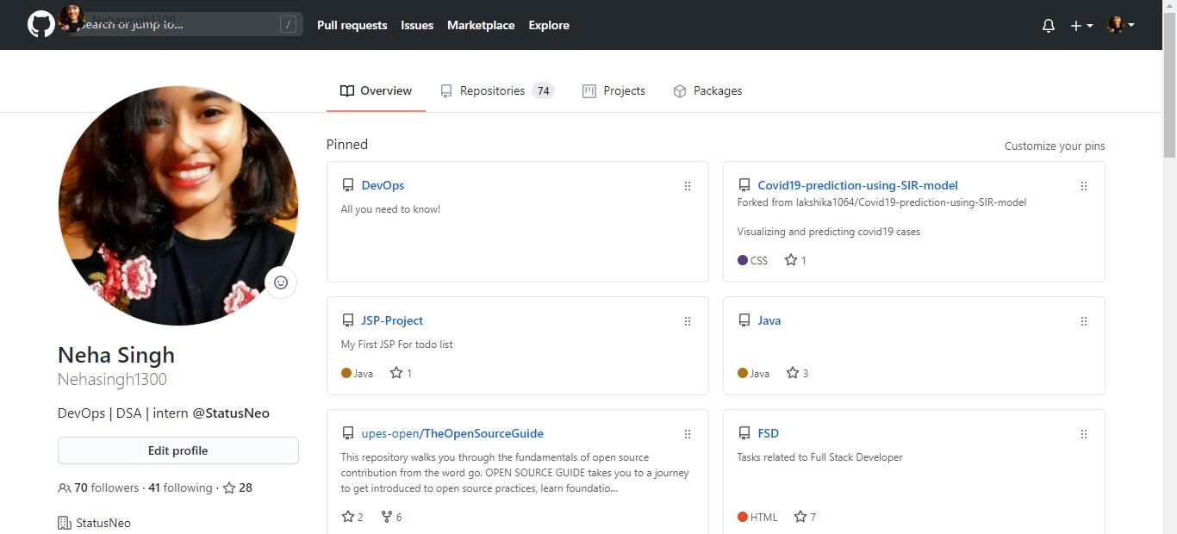

Now, you can move to the upper right-hand side and click on + sign to make new repo.

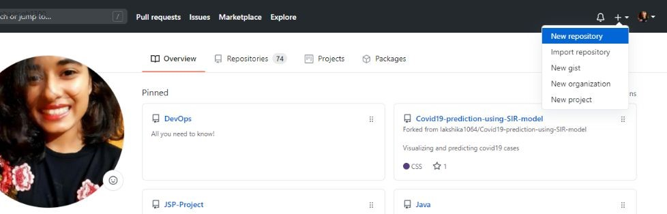

You can enter any name for your repository, and description if you want. Then, go and click Create Repositiory

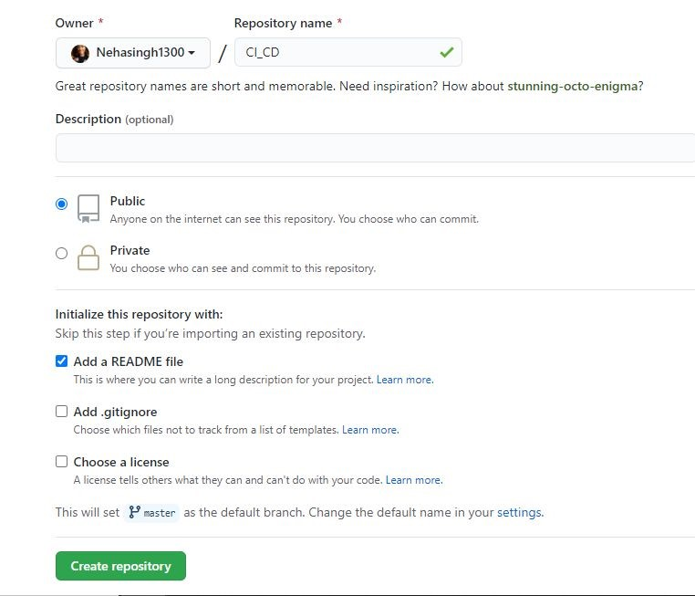

Now, move to Maven, where you have your maven project.

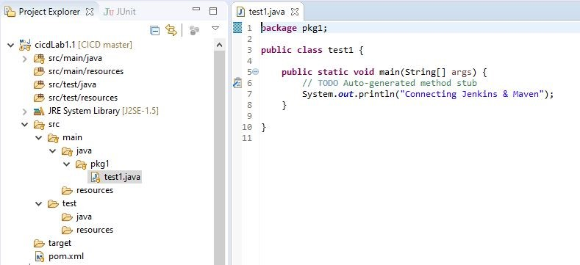

On the upper right-hand side search for git. Click on it.

Then click on the clone repository icon.

Enter the details and URL of your repository.

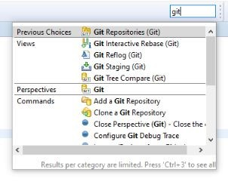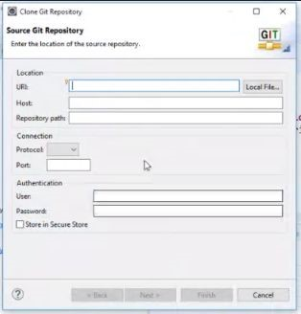

Go to your project and right-click on it.

Move to Team >> share project >> Configure GitHub Repository >> enter credentials

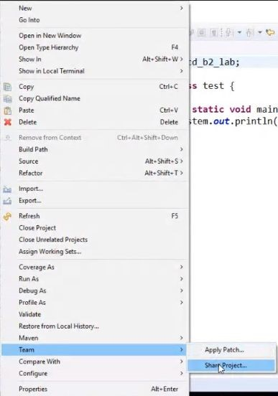

Configure Git Repository

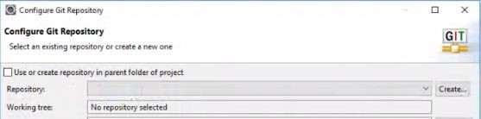

You will be able to see that your repository is connected with GitHub.

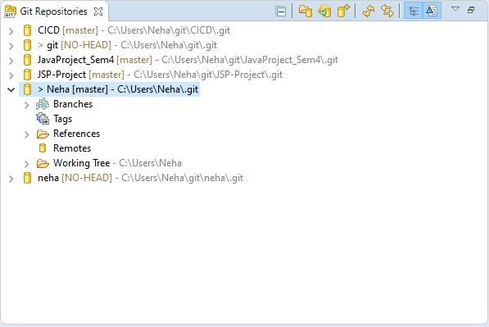

Now, drag all the changes from unstaged to staged. Enter the Commit message then click commit and push.

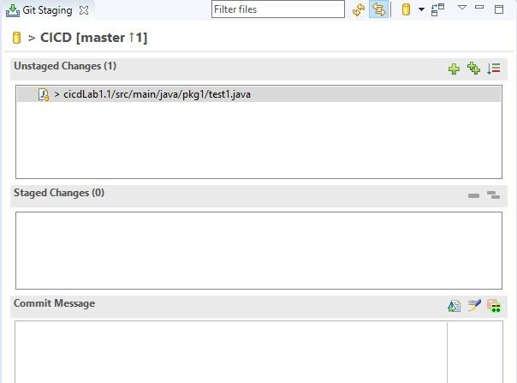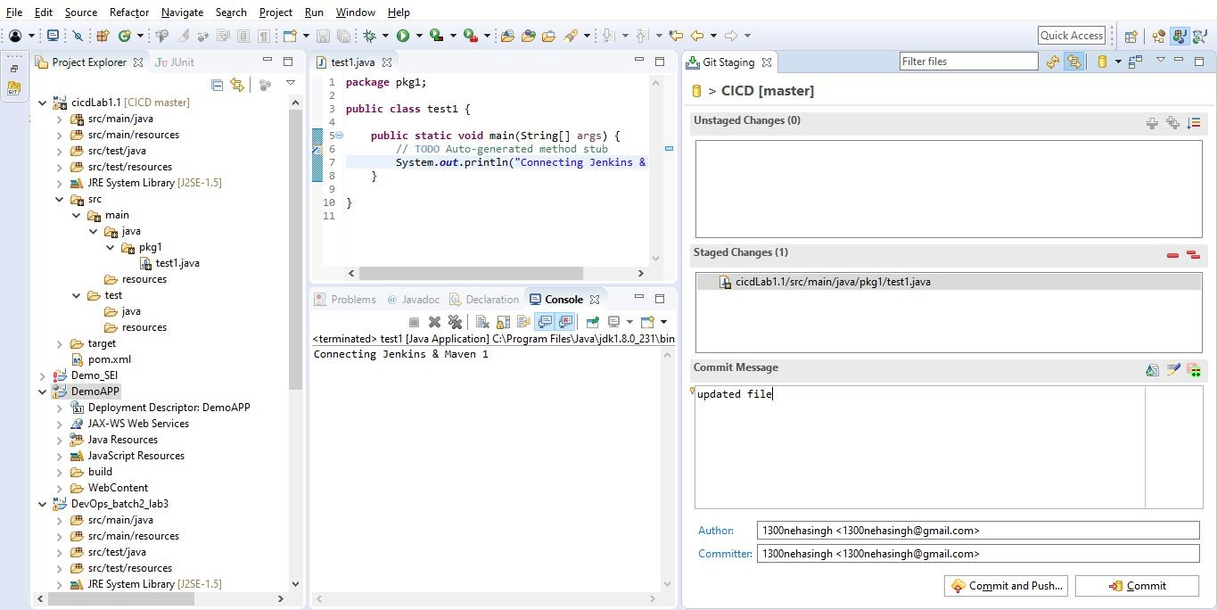

Enter

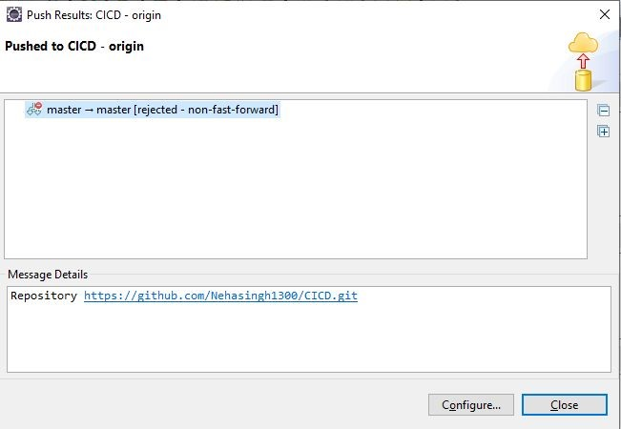

You can see all the changes in your repository.

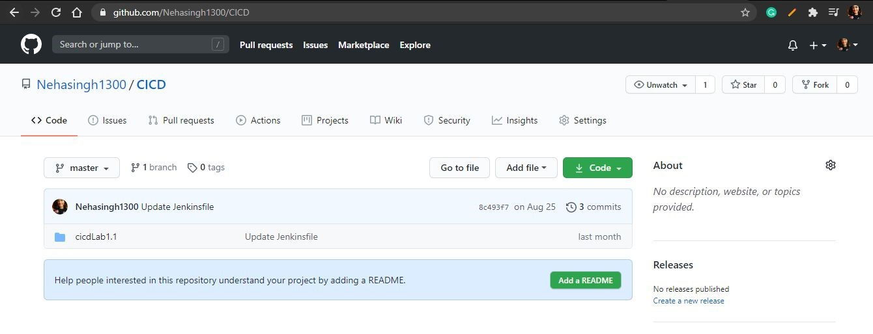

Move to new items

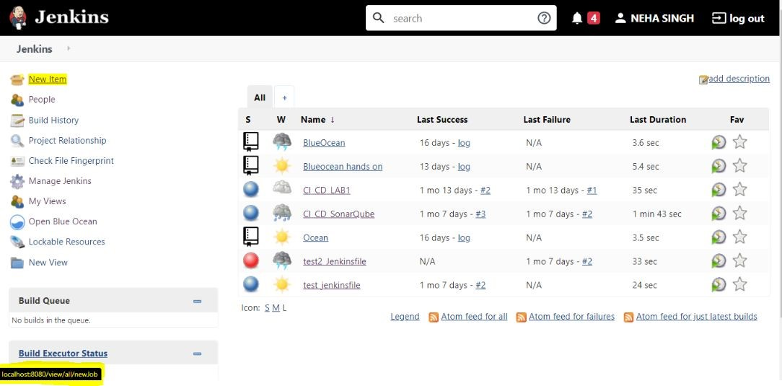

Select Maven Project and enter the name of the project.

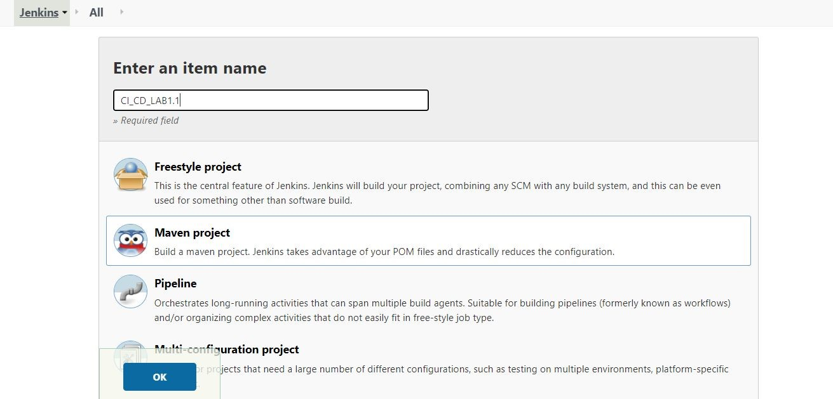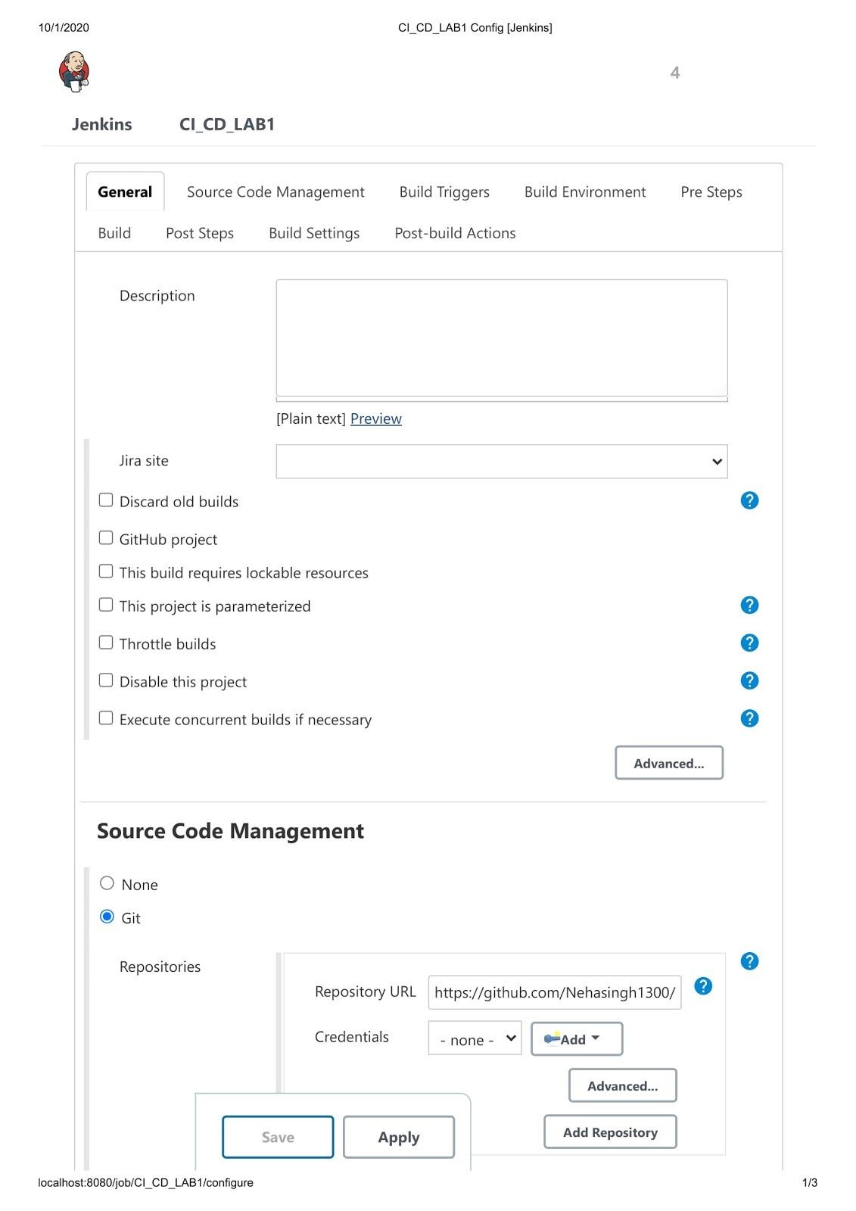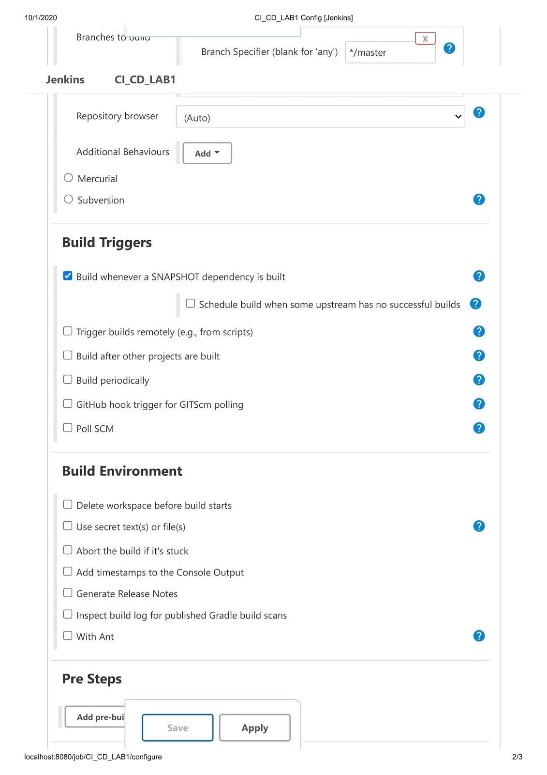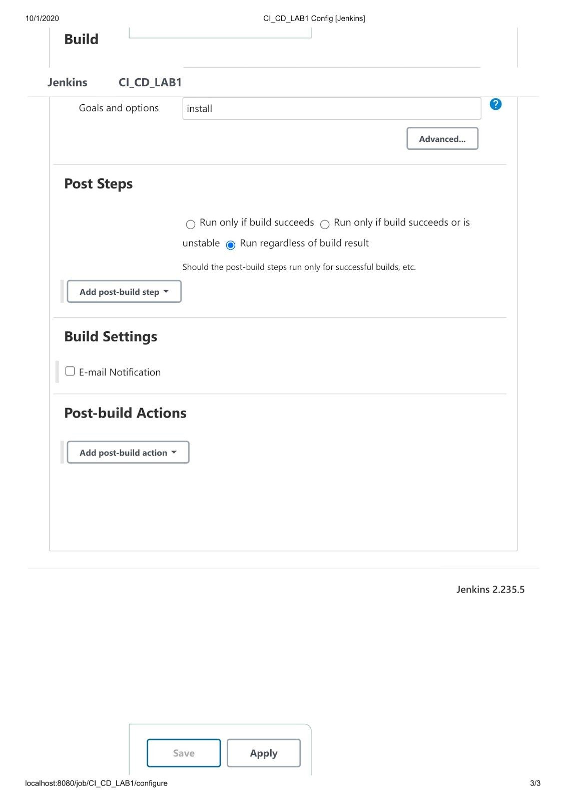

Now, you can see your project. Click on Build now

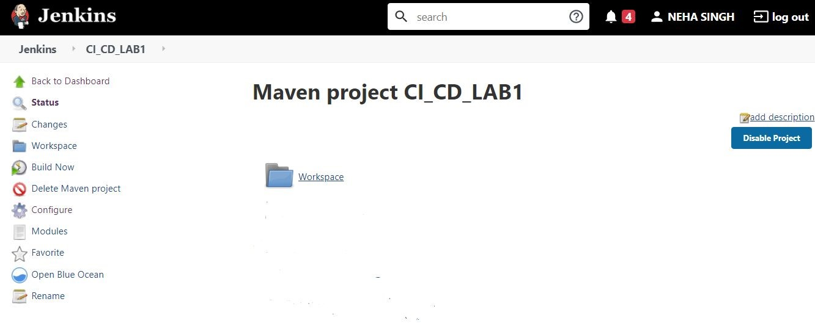

You wll be able to see Build Success if your project has no error, else go to error message and make suitable changes.

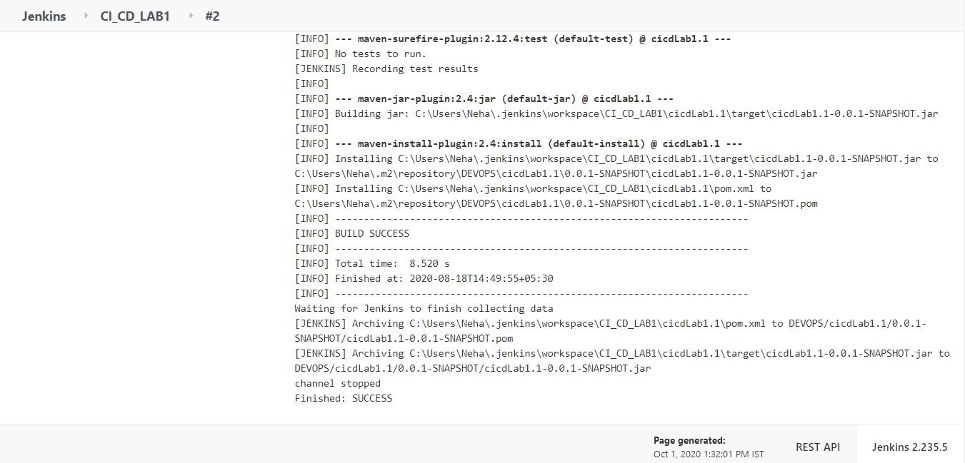

You can see the build artifact

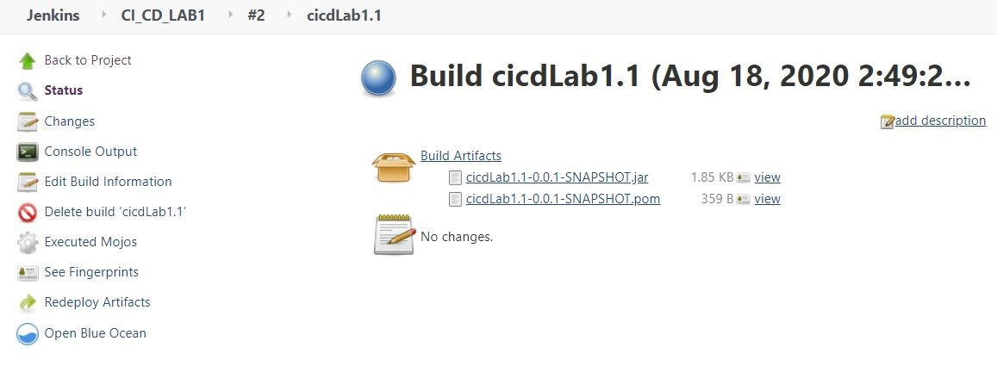

That’s all for this module.